COE 301 Project

Loay Shqair, 202365030

Design and Implementation
Note that due to how ROM works in Logisim, ROM is 16-bit addressable. Thus, PC is incremented by 1 (not 2). There is no need to shift the immediate field in branch and jump instructions. When using JALR, one should save PC+1 (not PC+2). Similar notes on addressing also apply to RAM.

Drawings of Components
All circuits used in the project are provided in the folder
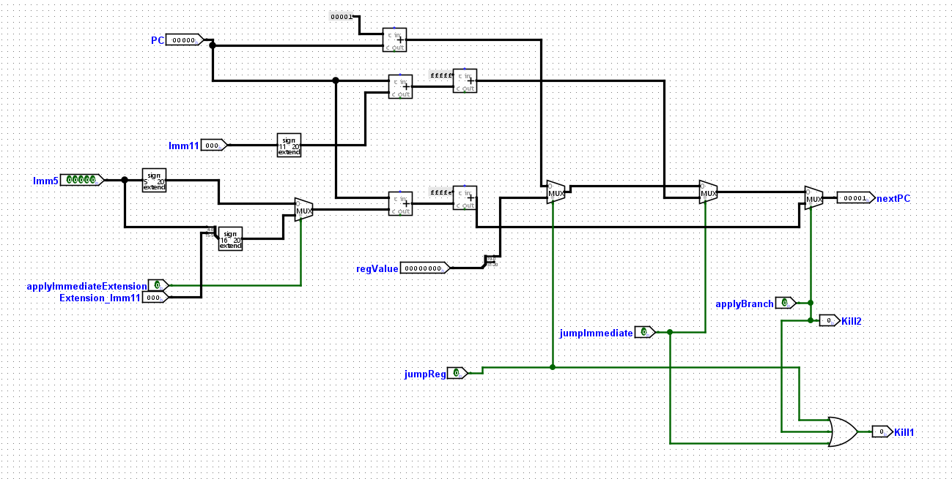
Instruction split
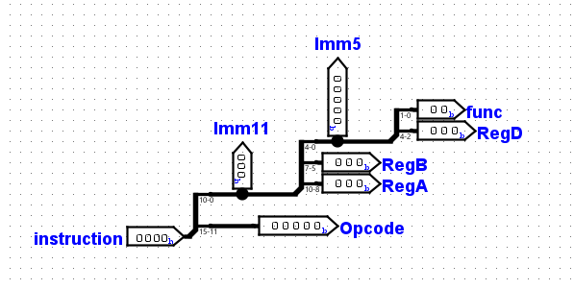
ALU Control
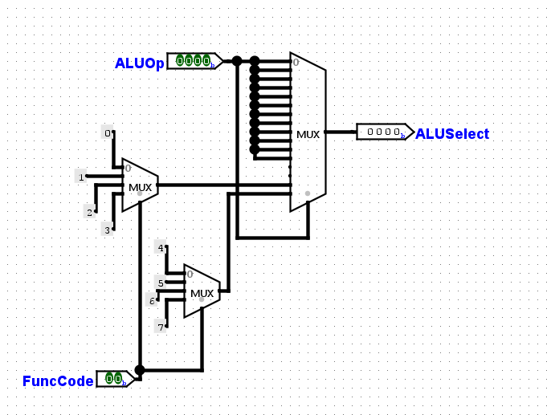
Immediate Logic (do not include immediate extension with shift operations)
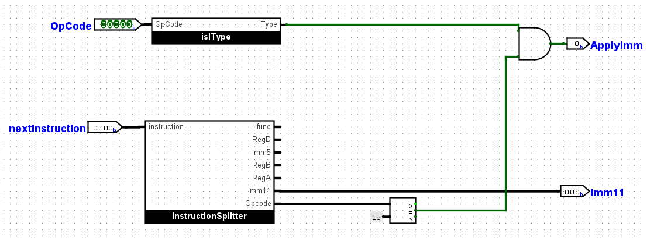
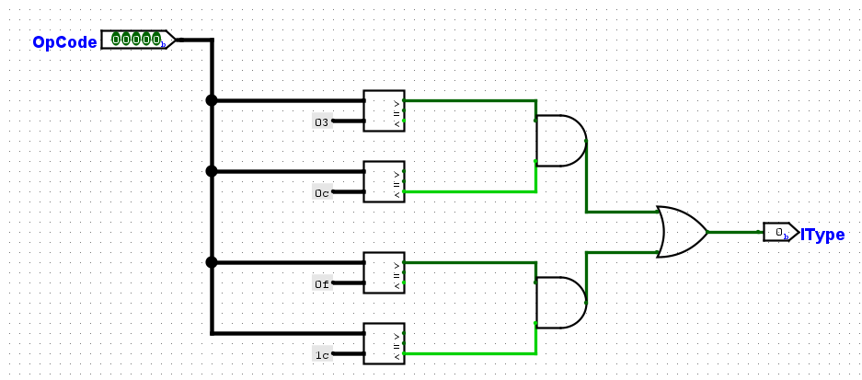
Forward logic (we acknowledge that we could’ve used priority encoders to implement it)
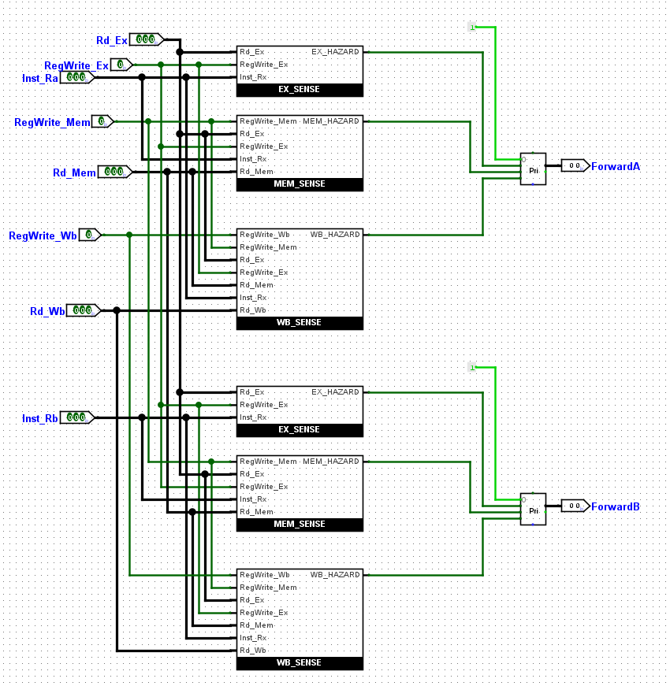
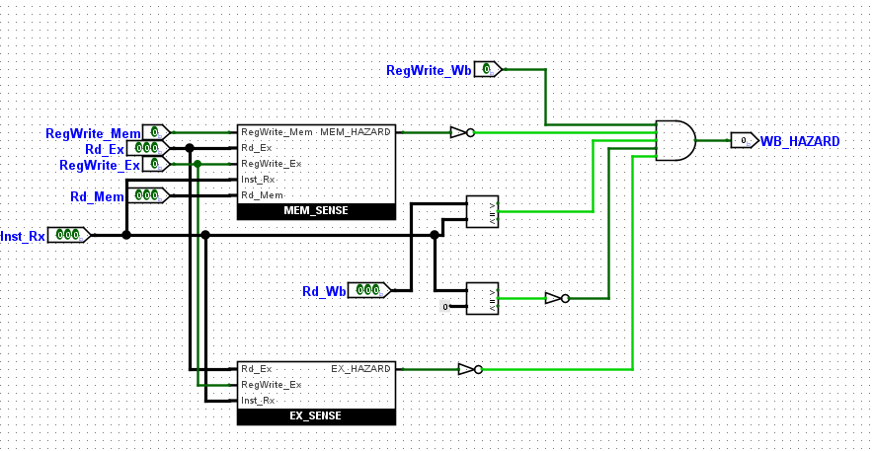
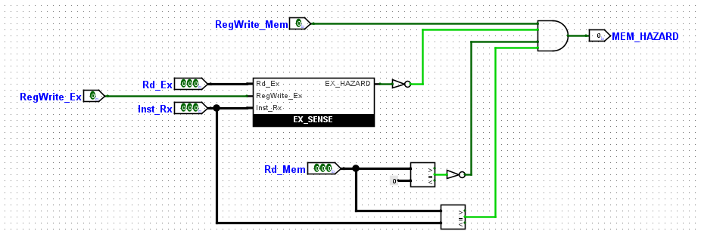
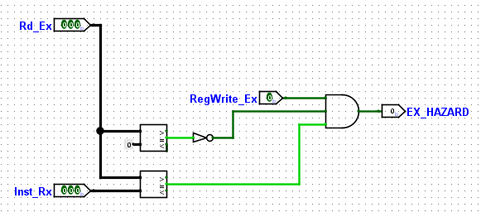
Branch Control (could’ve been part of the PC control module)
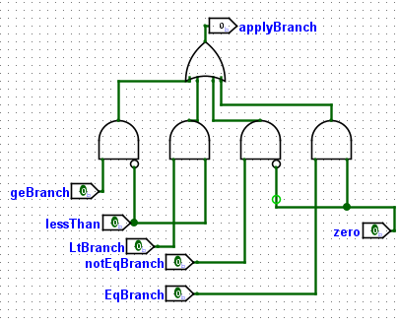
Main Control
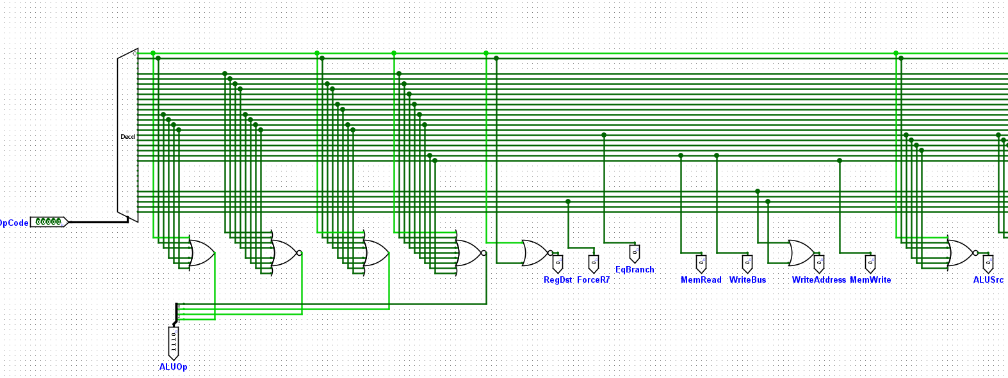
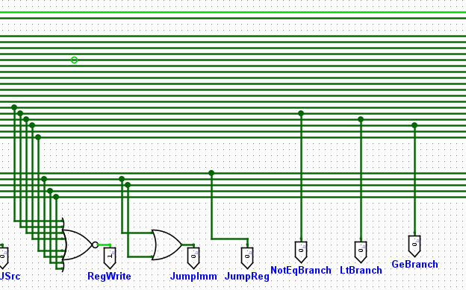
Register file
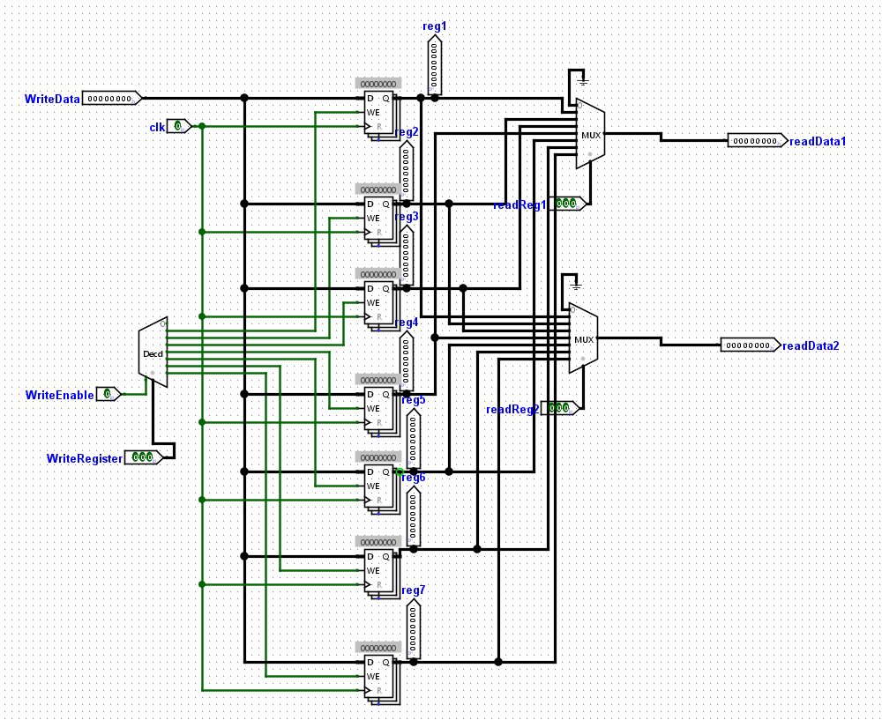
ALU
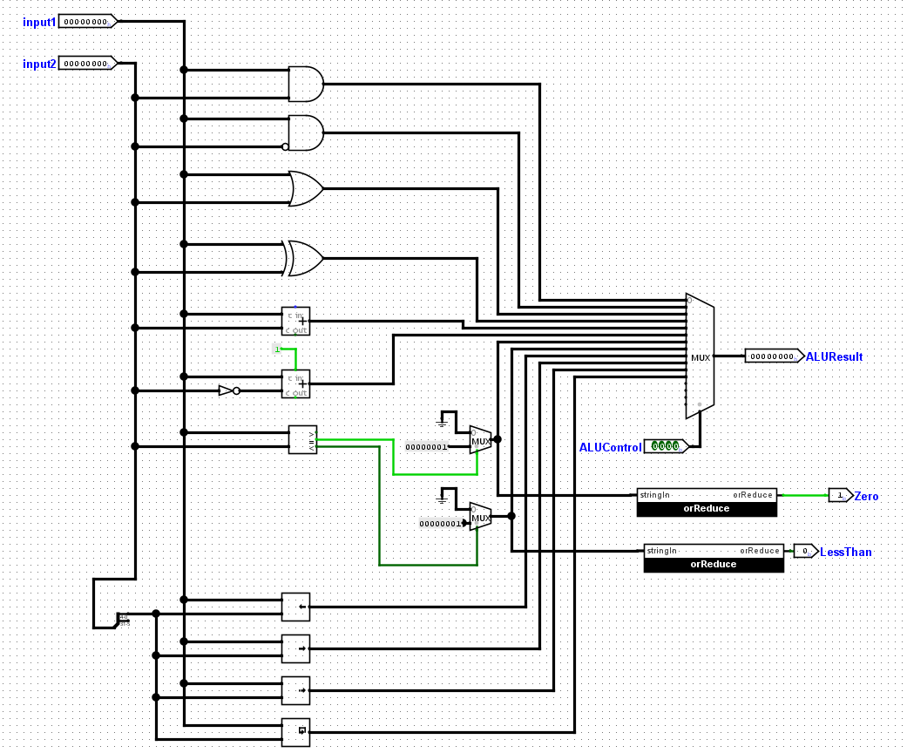
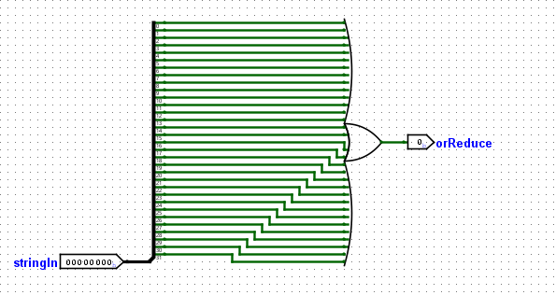
PC control (Single-Cycle)
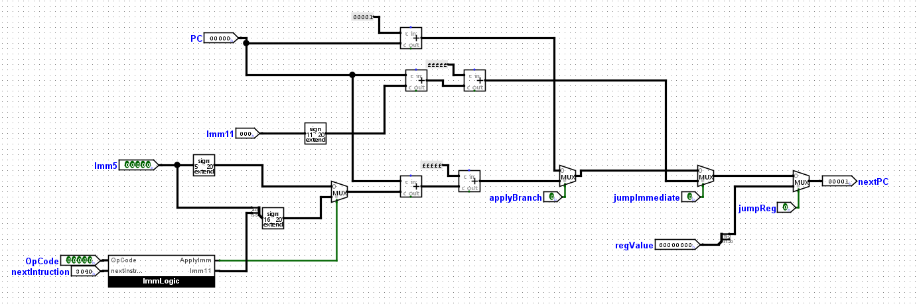
PC control (Pipeline)
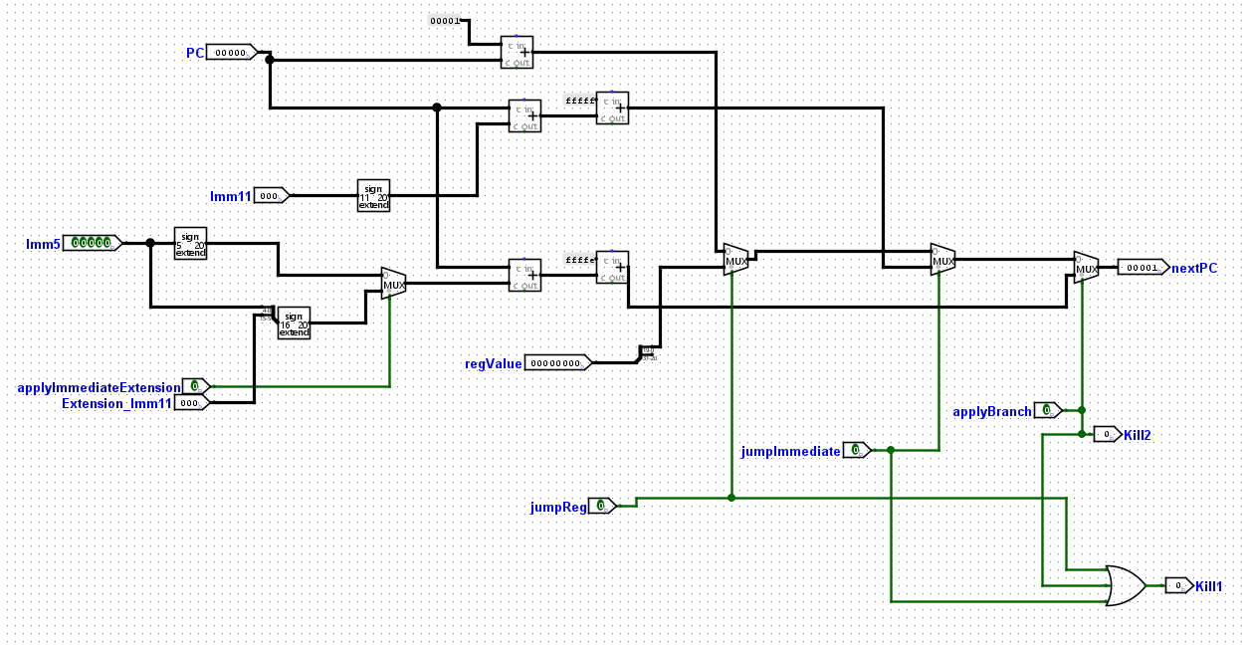
Datapath (Single-Cycle)
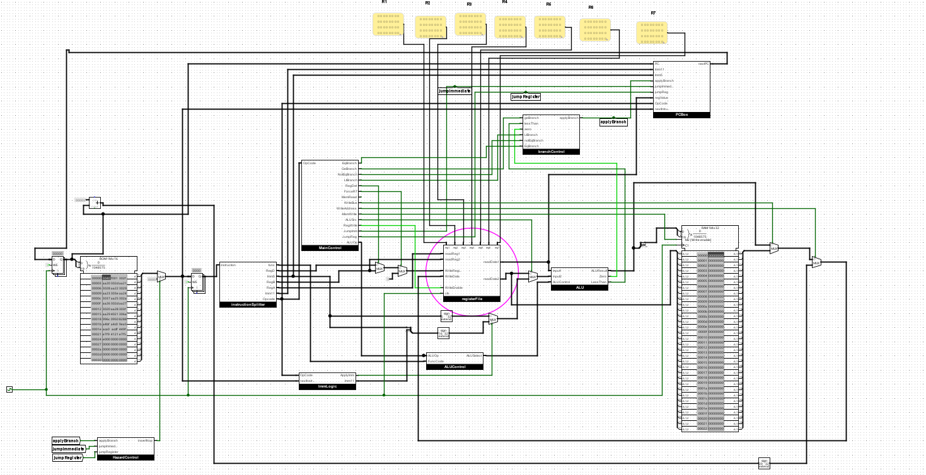
Datapath (Pipeline)
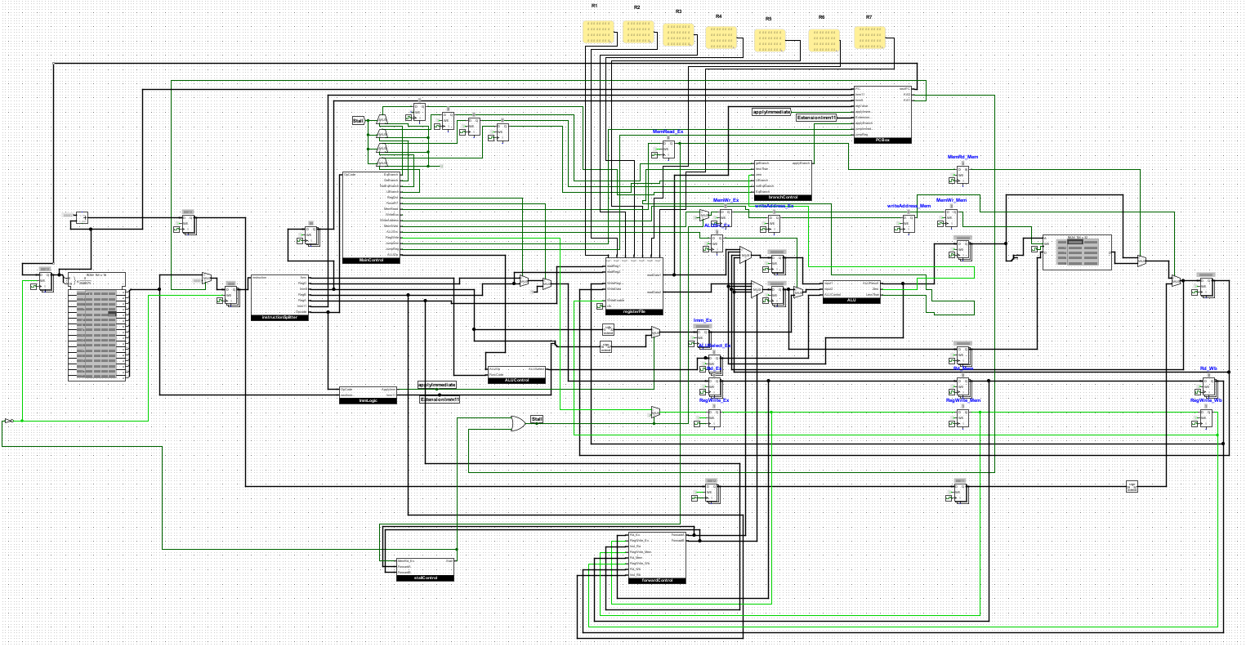

Control logic Description
controlSignals.xlsx in the folder provides the control signals

Forward Logic and Hazard Control
We referred to Dr. Aiman’s slides to implement both the forward control and the hazard control in the pipelined processor

Forward Logic
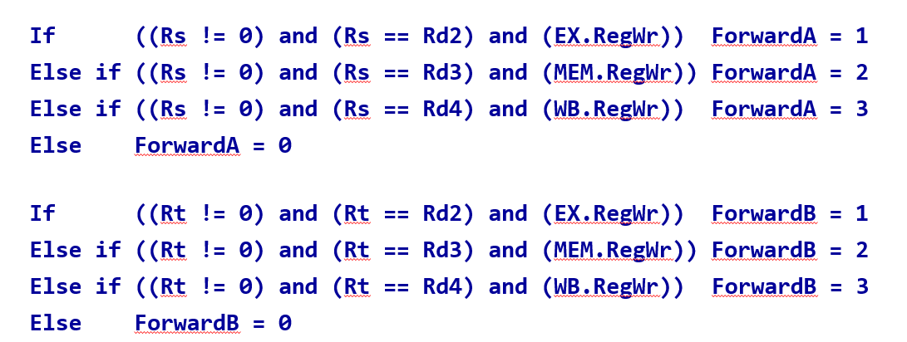

LW Stalling
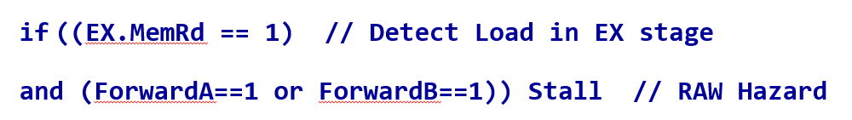

Control Hazard
Note that we have 4 branch instructions, so instead of or-ing only two terms as in the slides (BEQ and BNE), we or 4 terms for BEQ, BNE, BLT, and BGE. Also, we have different jump instructions and we take them into account.
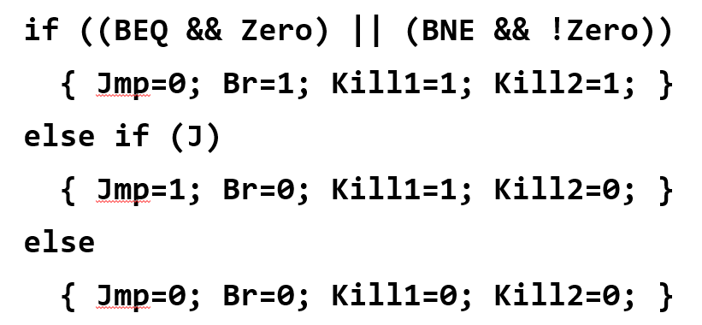

Simulation and Testing

Test Programs
See instructions.txt for test programs run
In this document we provide screenshots for the last test program in instructions.txt (Insertion Sort). The program stores 10 random values starting from index 0x20 in RAM. Then sorts them using the insertion sort algorithm.

Assembly Code
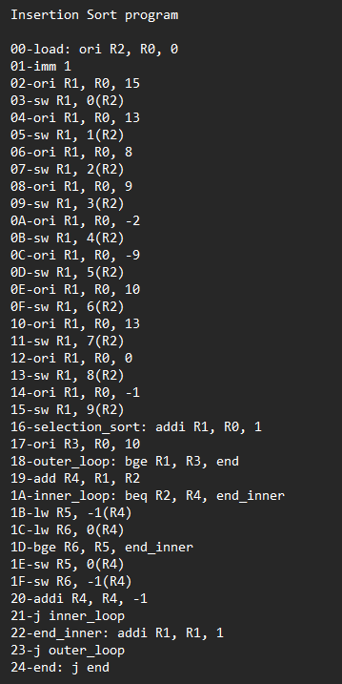

Machine Code
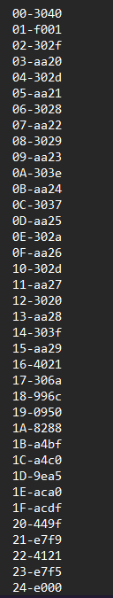
Final State of RAM (Single-Cycle)
Final State of RAM (Pipeline)

Hazard/Edge cases
As stated before, we implemented forward logic, stall logic, and control hazard logic

Snapshots
Snapshots for the insertion sort program provided in the document

